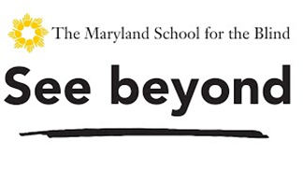

The Maryland School for the Blind Beep Baseball Classic

You are invited to attend a Beep baseball clinic. In conjunction with League of Dreams and the Baltimore Orioles MSB will be hosting a baseball clinic.

When: September 12th at 10:00am-12pm

Where: Cal Ripken Sr. Athletic Complex at The Maryland School for the Blind.

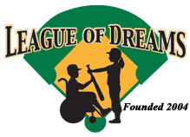**Email if you have any questions at:**

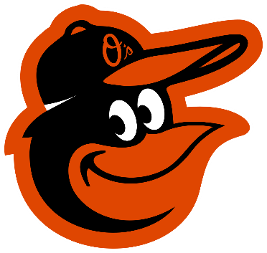[**timothyt@mdschblind.org**](mailto:timothyt@mdschblind.org)

[**Chrisw@mdschblind.org**](mailto:Chrisw@mdschblind.org)

[**Andrewf@mdschblind.org**](mailto:Andrewf@mdschblind.org)

www.marylandschoolfortheblind.org

**(This institution is an equal opportunity provider.)**